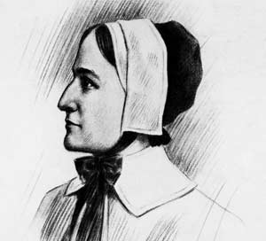 | Anne Hutchinson (1591-1643)  [Argue that your choice is healthier by siding with the dietitian in your group]  - Daughter of a militant Presbyterian who was attacked by the Church of England  - Arrived at Massachusetts Bay in 1634  - Hosted meeting at home for women to discuss sermons
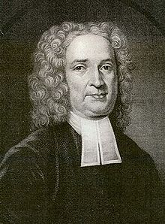 | John Cotton (1585-1652)  [Convince your group by playing the role of a dietitian]  - A scholar and theologian who had studied at Cambridge, then the hotbed of Puritanism  - Arrived at Massachusetts Bay in 1632  - Attempted to change the church from within
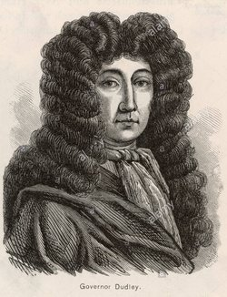 | Thomas Dudley (1576-1653)  [Create rules (budget, convenience, ambiance, etc.) about where to go for dinner but are open for suggestions]  - Founder of Cambridge, Massachusetts and many times Governor of Massachusetts Bay Colony  - Arrived at Massachusetts Bay with Winthrop on the Arbella in 1630  - Defended Puritan faith rigorously
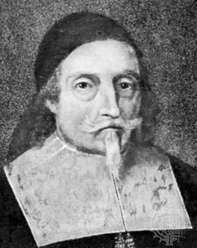 | John Endecott (before 1600-1664/1665)  [Embrace rules and defend them; can get hot-tempered sometimes]  - the longest serving Governor of Massachusetts Bay Colony  - Arrived at Salem, Massachusetts in 1629  - More radical than orthodox Puritans; might even be a separatist.
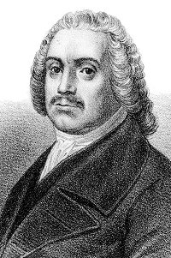 | Roger Williams (1603-1683)  [Have a taste for exotic cuisine]  - Founder of Rhode Island  - Arrived at Salem, Massachusetts in 1630  - Proposed separatism and a truly consent-based religious community
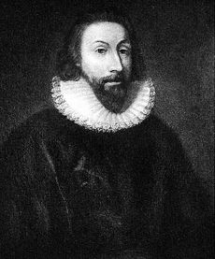 | John Winthrop (1587-1649)  [Believe that everything’s God’s providence/plan]  - Leader onboard the Arbella  - Founder of the Massachusetts Bay Colony  - Hated anyone who challenged his authority

